 

###### Cairo University

###### Faculty of Computers and Artificial Intelligence Artificial Intelligence Department

Pet Care Application

#### Implemented By:

|  |  |
| --- | --- |
| **Yasmin Yousry** | **20200829** |
| **Kareem Khalid** | **20190654** |
| **Adham Hassan** | **20200065** |
| **Amgad Essam** | **20200092** |
| **Mohamed Bashir** | **20200788** |

#### Supervised By: Dr. Hoda Onsi

##### Graduation Project Academic Year 2023-2024

##### Abstract

This project represents a transformative initiative in the domain of pet ownership, aiming to enhance the overall experience for pet owners. This comprehensive platform integrates innovative features to streamline pet care, including convenient access to pet supplies, personalized expert guidance, and pet services. The project places a strong emphasis on improving pet well-being by establishing a centralized platform for purchasing pet supplies, the application ensures users can easily procure high-quality products to meet their pets' needs. The inclusion of an AI-powered chat expert further empowers users with real-time assistance on various aspects of pet care. This holistic approach creates a robust ecosystem, convenience, and improved well-being for pets and their dedicated owners. The project signifies a significant step forward in redefining pet care practices, offering an inclusive solution that combines accessibility, expertise, and community collaboration.

**Contents**

Chapter1: Introduction 6

1.1 Background 6

1.2 Scope 8

1.3 Objectives 8

1.4 Significance of the Project 8

Chapter2: Literature overview 10

2.1 Introduction: 10

2.2 Pet Care Industry Trends: 10

2.3 Existing mobile application in Petcare: 10

2.4 Chatbot Technology and its Applications: 10

2.6 User Behavior and Preferences: 11

2.7 Technological Considerations: 11

2.8 Gap Analysis and Proposed Application Design: 11

2.9 Research Questions and Hypotheses: 12

Chapter 3: Problem Statement 13

3.1 Identification of the Problem: 13

3.2 Motivation for the Project: 13

3.3 Features of the application: 13

Chapter4: proposed system 15

4.1 Methodology 15

4.1.1 Development tools and technology 15

4.1.2 Data collection: 16

4.1.3 System architecture: 17

4.2 Requirements: 19

4.2.1 Functional requirements: 19

4.2.2 Use cases: 19

4.2.3 class diagram: 21

4.2 ,4 sequence diagram: 22

4.3 Design and Implementation: 22

4.3.1 User Interface Design: 22

4.3.2 System Architecture Implementation: 23

4.4 Integration of Mobile App and Chat bot: 24

4.4.1 Communication Protocols: 24

4.4.2 Data Flow Between Mobile Application and Chat bot: 25

Chapter 5: Conclusion 27

5.1 Contributions of the Project: 27

5.2 Progress: 27

5.3 Future work : 28

Chapter 6: References 29

6.1 References links: 29

# Chapter1: Introduction

## Background

In this modern generation, raising a pet is a fascinating thing. Many people prefer raising a pet. It is one of the status symbols in this society. Be it the Urban or rural areas, people from all over are interested in raising pets. Having a pet in the house changes the atmosphere and mentality of the family members. In some cases, having a pet creates a bond within the family members.

Therefore, millions of people worldwide love their pets, enjoy their companionship, playing, going on walks and no wonder talking to them. According to the research, attachment to pets is good for human health and builds community. Raising pets brings closeness within the family members. Thus, it creates healthy emotional connections among people. Many health benefits happen when there is an emotional attachment with pets. Therefore, we start to care and protect the most for animals that live with us.

The bond between humans and animals is not good for human health. It also helps to create community. It has proved that affectionate folks with their pets develop connections with people. Raising a pet and sharing life with a pet has been found with a decreased risk of arteria coronaria disease and a discount in stress levels. Increased physical activity, especially while dog walking. People owning a pet has found that with an improved disorder among the older adults, also being treated with hypertension.

In recent years, there has been a noticeable increase in the number of individuals welcoming pets into their homes. As more people adopt pets, the need for effective pet care solutions has become increasingly evident. To address this growing demand, our graduation project aims to develop a comprehensive Pet-Care Application—a digital tool designed to assist pet owners in raising and caring for their beloved companions.

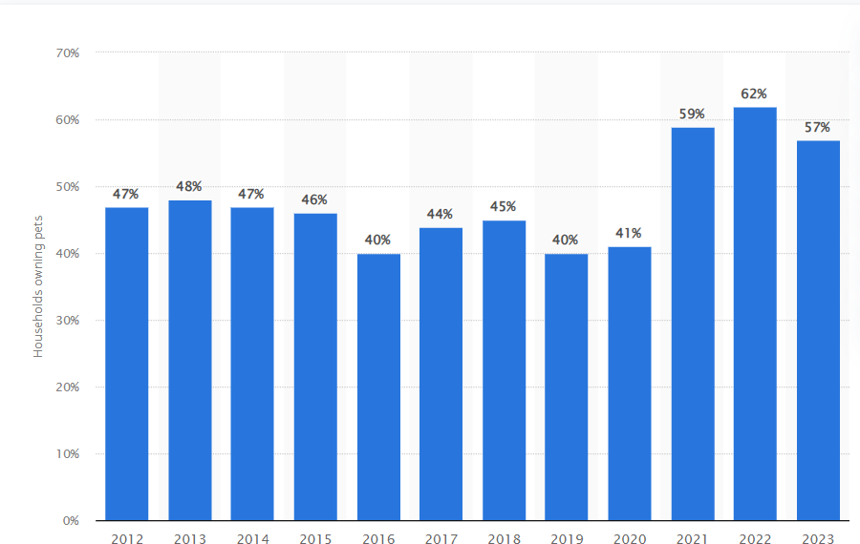

**Figure 1: Share of households owning a pet in the United Kingdom (UK) from 2012 to 2023**

## Scope

The Application aims to transform the pet ownership experience by providing a user-friendly platform focused on essential features. Our goal is to empower pet owners primarily through streamlined access to pet supplies, essential services, and personalized advice. The scope of the application includes integration for purchasing quality pet supplies, important pet services such as pet search and pet adoption, and an AI-powered chat expert offering real-time assistance.

Tailored for pet owners of all experience levels, the application seeks to enhance convenience and accessibility while recognizing the significance of professional veterinary advice. The project endeavors to create a practical and efficient solution, fostering a strong connection between pets and their owners.

## Objectives

The primary objective of our project is to provide a comprehensive solution for pet owners, assisting them in raising and caring for their pets. The application aims to simplify the challenges associated with pet ownership by offering a range of tools and resources. Moreover, assistance of AI like a real expert to help pet owners. The goal is to empower pet owners with the information and support needed to make informed decisions regarding their pets' health, behavior, and overall well-being.

## Significance of the Project

The Pet Care Application holds substantial significance in the realm of pet ownership by addressing key challenges and enriching the overall experience for pet owners. In a landscape where pet care involves multifaceted responsibilities, this application stands out as a pivotal tool that combines convenience, accessibility, and expert guidance.

Firstly, the application streamlines the process of acquiring pet supplies and essential services. By integrating a seamless e-commerce platform, pet owners gain quick and convenient access to quality pet products, ensuring the well-being and comfort of their pets.

Secondly, the application's AI-powered chatbot adds a layer of personalized assistance. This feature serves as a valuable resource for pet owners seeking real-time advice on a range of topics, including health concerns, caring advice, feeding, grooming, and environmental hygiene. The chatbot enhances the user experience by providing reliable and instant support, fostering a sense of confidence and knowledge among pet owners.

Moreover, the application extends its impact by seamlessly integrating essential pet services. By providing a platform for various services, it enhances convenience and accessibility for pet owners. The innovative pet search feature utilizes AI algorithms to help locate lost pets efficiently by analyzing uploaded images. This significantly increases the chances of a swift reunion, offering peace of mind to pet owners during stressful situations.

Additionally, the application's community feature fosters a supportive environment where pet owners can connect, share experiences, and access valuable information. This aspect of the application promotes a sense of belonging and mutual support among users.

Overall, the Pet Care Application offers a comprehensive solution for various aspects of pet care, combining advanced technology with practical resources to improve the quality of life for both pets and their owners. This streamlined approach not only contributes to the well-being of pets but also alleviates the administrative burden on pet owners, making pet care more manageable and enjoyable.

# Chapter2: Literature overview

## Introduction:

The pet care industry is experiencing a boom, driven by rising pet ownership, increased disposable income, and pet humanization. With busy lifestyles and demanding schedules, pet owners seek innovative solutions to manage their furry companions' needs. Mobile applications have emerged as valuable tools, offering features like appointment scheduling, pet tracking, and product recommendations. However, there exists a gap in personalized guidance, real-time support, and comprehensive health monitoring. This literature overview delves into the current landscape of pet care mobile applications, explores the potential of chatbot technology in this domain, and introduces a proposed application design that bridges these identified gaps.

## Pet Care Industry Trends:

* + - Global pet care market to reach $326 billion by 2027 (Reportlinker, 2022).
    - Growing pet ownership, particularly among millennials and Gen Z (American Pet Products Association, 2023).
    - Increased spending on pet products and services due to pet humanization trends.
    - Busy lifestyles and travel needs create challenges for pet owners.

## Existing mobile application in Petcare:

* + - Popular examples include Rover, Wag, Chewy, and PetDesk.
    - Offer features like appointment scheduling, pet tracking, product recommendations, and community forums.
    - Strengths: convenience, access to information, and basic management tools.
    - Limitations: lack personalized guidance, real-time health monitoring, and comprehensive support.

## Chatbot Technology and its Applications:

* + - Chatbots offer 24/7 support, answer FAQs, and automate tasks across various industries.
    - Limited examples in pet care: "Pawsome Chat" for basic advice, "AskVet" for virtual vet consultations.
    - Research suggests chatbots can improve user engagement and satisfaction (Juniper Research, 2023; International Journal of Human-Computer Interaction, 2020).

## User Behavior and Preferences:

* + - Studies indicate pet owners seek personalized content, real-time updates, and convenient access to information (Rover, 2022; Digital Journal of Social Networking and Applications, 2020).
    - Growing demand for chatbots in pet care for basic advice, appointment scheduling, and emotional support (Rover, 2022).

## Technological Considerations:

* + - Advancements in mobile app development, AI, and NLP offer opportunities for enhanced pet care applications.
    - AI can personalize content and recommendations, while NLP enables chatbots to understand complex questions (Gartner, 2023; Forbes, 2023).

## Gap Analysis and Proposed Application Design:

* + - Existing apps lack AI-powered personalized guidance, real-time health monitoring, and comprehensive chatbots.
    - The proposed application aims to address these gaps by:
    - Implementing an AI-powered chatbot that provides personalized pet care advice, answers specific questions, and offers emotional support.
    - Integrating real-time health tracking features, including activity monitoring, weight updates, and mood indicators.
    - Utilizing advanced NLP to ensure the chatbot accurately understands complex user inquiries and provides relevant responses.

## Research Questions and Hypotheses:

* + - RQ1: Does integrating an AI-powered chatbot into a pet care mobile application increase user engagement and satisfaction?
      * H1: Users engaged with the chatbot will exhibit higher app usage and report greater satisfaction compared to users without chatbot interaction.
    - RQ2: Can real-time health tracking features within the app improve pet owners' awareness and timely response to potential health concerns?
      * H2: Users who utilize the health tracking features will demonstrate increased knowledge of their pet's health and seek veterinary care promptly when needed.

# Chapter 3: Problem Statement

## Identification of the Problem:

In contemporary society, the role of pets as valued family members has evolved, and so too have the challenges associated with their care. The identification of the problem at hand involves recognizing the multifaceted nature of pet care, from health management to routine tasks. Pet owners often grapple with fragmented information, making it challenging to maintain a cohesive approach to their pets' well-being. The lack of a chat bot centralized system for organizing pet-related data hinders the ability to provide optimal care.

Pet health records, and activity routines are scattered across various platforms, notes, and memory, leading to inefficiencies and potential oversights. The identification of these challenges establishes the need for a holistic and integrated solution to streamline pet care processes.

## Motivation for the Project:

The motivation behind developing chatbot for pets a is rooted in the transformative impact it can have on the lives of both pets and their owners. As the number of pet owners continues to rise, so does the desire for a tool that not only simplifies the complexities of pet care but also enhances the overall experience.

Pets are cherished companions, and their well-being directly correlates with the happiness and satisfaction of their owners.

The project's motivation is fueled by a commitment to addressing the evolving needs of modern pet ownership. The pet care app aims to bridge the gap between traditional pet care methods and the convenience afforded by technology. By offering a comprehensive and user-friendly platform, the app seeks to empower pet owners, fostering a sense of confidence and control in providing optimal care for their beloved animals.

## Features of the application:

* Pet Supply: Access to a variety of pet supplies available for purchase within the application.

The pet supply page consists of list of products each product link you to a page where display product name , price, link to the product website, description, category of the product

* Pet Services: Availability of various services such as clinic information (which include clinic phone number , address and the link to their website or application)
* Chatbot: An AI-powered chatbot to assist users with pet-related queries. Users can ask the chatbot questions regarding their pet's health, care advice, feeding, grooming, and environmental hygiene. The chatbot provides accurate and personalized answers based on the pet type (cat, dog, or bird).
* The chatbot features include:
  + - Understanding Your Pet's Needs: The chatbot guides users in decoding their pet's behaviors and needs. It, facilitating better communication between the owner and their pet.
    - Health Management: The chatbot provides information on a wide range of health issues such as respiratory infections, dental health, obesity, parasitic infections, kidney disease, diabetes, hyperthyroidism, cancer, allergies, and mental health issues including anxiety and depression. It offers preventative care advice and treatment options.
    - Feeding and Diet: The chatbot gives recommendations on feeding and diet for different types of pets, including weight management and nutritional advice.
    - Exercise and Play: It suggests exercise routines and play activities suitable for cats, dogs, and birds to ensure they remain active and healthy.
    - Training: The chatbot provides training tips and techniques for pets, enhancing their behavior and obedience.
    - Grooming and Hygiene: It offers guidance on grooming activities like nail trimming, fur grooming, bathing, and maintaining ear and eye care. It also covers hygiene practices such as litter box maintenance for cats, and cage cleaning for birds.
    - Environmental Care: The chatbot assists in maintaining a healthy environment for pets, including bedding, toys, and both indoor and outdoor spaces. It emphasizes the importance of environmental hygiene for overall pet well-being.
* Community: A platform for pet owners to connect, share experiences, and support each other.

Where each user can create a post contain information about what the user interested in , date of the post created and the username , other users can see the post and comment on it

* Pet Search: A feature that helps locate lost pets using pet matching algorithm by analyzing the images provided by users. Users can upload an image of their lost pet, and the system utilizes pet matching algorithm to help locate the pet. By searching in the database of lost cats and dogs.

# Chapter4: proposed system

## Methodology

### Development tools and technology

1. **Flutter:** IS an open-source software development toolkit developed by google. It is used to develop applications for the following platforms: web, mobile and desktop from a single codebase. It allows the developers to write the code once and deploy it across multiple platforms, which can save time and resources. Flutter uses dart programming language. In our application the usage of flutter is for designing the (GUI), flow and the logic of the application.
2. **Firebase:** is a set of backend cloud computing services and application development platform provided by google for building and managing mobile and web applications. It provides a wide range of features and services to streamline application development and enhances application quality. In our PetCare application firebase is used with flutter to be a backend server side that manages the application. It provides a set of services such as **authentication service:** This service is used in our application to enable users to create accounts. It simplifies the process of implementing user authentication and authorization in our application by providing secure and reliable user management features.

**Firestore service:** Is Firebase's scalable and flexible NoSQL document database. It offers more advanced querying capabilities and hierarchical data structures compared to the Realtime Database. In our application firestore is used to store the user profile’s data, this enables storing more information about the user that needed in the application. There are many services provided by firebase (Realtime Database – cloud storage) and other services.

1. **Visual studio code:** Is the integrated development environment (IDE) used in the development process of the application. Vs code is popular and powerful source-code editor developed by Microsoft. It is known for its lightweight nature, extensive customized options and wide range of features that enhance the coding experience. One notable aspect is its capability to utilize extensions for customizing the editor to suit programming languages, frameworks, and workflows. In Visual Studio Code, the presence of Dart and Flutter extensions significantly enhances the development experience by providing invaluable support for these technologies.

These extensions not only integrate seamlessly with the editor but also offer intelligent features that streamline code writing. Dart and Flutter extensions in Visual Studio Code offer robust support for developers working with these languages and frameworks. They facilitate code writing by offering intelligent suggestions for keywords, syntax, and code snippets specific to Dart and Flutter development. This feature significantly accelerates the coding process, reducing errors and improving overall productivity.

###### *For chatbot development

1. **Rasa:** Handles the natural language understanding and dialogue management for the chatbot.
2. **Python language:** Handles the natural language understanding and dialogue management for the chatbot.
3. **Ngrok:**
4. **Trensflow and Keras:** TensorFlow and Keras are employed to develop and deploy the deep learning models used for feature extraction from pet images. These models are trained to recognize distinctive features, enabling accurate image matching.
5. **OpenCV:** OpenCV is utilized for image preprocessing and handling. It reads, decodes, and processes images, converting them into a format suitable for feature extraction and similarity calculation.
6. **fast API:** FastAPI is used to build the backend server, which handles image uploads, processes the images, and returns the top matches. FastAPI's asynchronous capabilities ensure efficient handling of multiple requests.

*Corporation method

1. **Version control system with Git:** Throughout the development process, we utilized Git as our version control system to manage and track changes in the project codebase. Git played a pivotal role in facilitating collaboration and ensuring the integrity of our code. Here are the key aspects of our version control workflow:

**Code Repository:** We maintained a centralized Git repository on GitHub to host our project code. This centralized repository served as the primary location for storing, sharing, and collaborating on code changes among team members.

**Branching Strategy:** We adopted a branching strategy based on Git branches to manage parallel development efforts and isolate features, bug fixes, and experimental changes. This approach allowed us to work on new features or fixes without disrupting the stability of the main codebase.

**Committing Changes:** Team members regularly committed code changes to the Git repository using descriptive commit messages. Each commit encapsulated a logical unit of work, making it easier to track and understand the evolution of the codebase over time.

**Pushing Changes:** After committing changes locally, team members pushed their commits to the remote GitHub repository. This action synchronized their local changes with the central repository, making them accessible to other team members and ensuring visibility into the latest updates.

**Pull changes and code reviews:** when one of the team members completes a new feature or fixes a bug or other code changes in his branch, he submits a pull request (PR) on the project's GitHub repository. **A pull request** is a formal request to merge the changes from the feature branch into the main branch (often called "master" or "main"). **Code Review Process:** After a pull request is submitted, team members review the proposed changes and provide feedback to the author. This feedback may include suggestions, improvements, concerns about code readability, or identification of potential bugs or issues. Code review often involves **collaborative discussions** between the author of the pull request and reviewers. Team members can comment directly on specific lines of code, ask questions, or request clarifications. Code reviews serve as a **quality assurance** mechanism to ensure that code changes adhere to coding standards, best practices, and project guidelines. By involving multiple team members in the review process, potential errors, inefficiencies, or design flaws can be identified and addressed before the changes are merged into the main codebase.

### Data collection:

###### *Purpose of Data Collection:

###### Chatbot:

The primary objective of data collection within the PetCare chatbot is to enhance its conversational capabilities and responsiveness. By collecting user interactions and queries, we aim to train and improve the underlying Rasa model. This training process involves exposing the model to a diverse range of questions related to pet care, allowing it to learn and adapt to various user inquiries.

1. pet search :

the primary objective of data collection within Petcare application pet search feature is to train face and landmarks detection model

1. Pet supply
2. Pet services

###### The specific purposes include:

**Model Training:** The collected data serves as a valuable resource for training the Rasa model, enabling it to understand and respond effectively to a wide array of questions and scenarios related to pet care.

**Enhancing Accuracy:** By analyzing user inputs and their corresponding responses, the model can refine its understanding of language nuances, context, and user preferences. This iterative learning process contributes to the continual improvement of the chatbot's accuracy in providing relevant and helpful information.

**Adapting to User Needs:** The diversity of questions posed by users helps the chatbot adapt to different communication styles and pet care requirements. This adaptability ensures that the chatbot remains a valuable and reliable resource for a broad user base.

###### Types of Data Collected:

###### Chat bot : User Input in Conversations: Data is collected when users engage in conversations with the chatbot by inputting text-based queries, comments, or requests. This method is fundamental to understanding user intent and refining the chatbot's language comprehension.

1. **Pet supply page:** E-commerce websites regrading pet supply(product description , price , name , category and product image )
2. **Pet services page:** Browser search for clinic information (such as address , telephone number , website link )
3. **Pet search:** images and annotations of cats and dogs.

###### Methods of Collection:

**For chatbot trained model:**

question is gathered through 2 websites :

1. https:/[/www](http://www.purina.co.uk/articles/cats).[purina.co.uk/articles/cats](http://www.purina.co.uk/articles/cats) : to gather different types of questions regrading petcare
2. https://quillbot.com/ : to paraphrase different ways to say the same question.

answers to corresponding question are gathered through: https:/[/www](http://www.purina.co.uk/articles/cats).[purina.co.uk/articles/cats.](http://www.purina.co.uk/articles/cats)

**For the application supply page**: gathered manually from online stores or e-commerce (jumia) we gather the product information (such as product description , price , name , category and product image ) through that information , we create database using firebase

**For the application services page**: gathered manually form the browser , searching for clinic information (such as address , telephone number , website link )

**For the pet search:**

Cats and dogs images dataset :” <https://www.kaggle.com/code/kairess/cat-hipsterizer>” ,” <https://universe.roboflow.com/jccalugasupeduph/dog-and-cat-face-detection>” .

### System architecture:

System overview: This system is developed to serve as an assistant to the people who have pets. Most of the people do not know how to take care of their pets, therefore our application provides features and services that are needed by customers in one application in a straightforward way

* + - 1. System components:

**User of the application:** The user is the main component in the system who the system is designed for. This component represents the end-users of your application, including pet owners, veterinarians and pet groomers.

The user interacts with the system with the application’s user interface (UI) .The user is allowed to use the system within the provided features and the authorized actions including (create a profile – explore products in some categories – search for missed pet – share his questions with other users).

###### Backend server:

The backend server side is the core infrastructure responsible for processing requests from clients, executing business logic, and managing data. It includes components such as application servers, APIs, and middleware responsible for handling communication between the frontend and the database. The backend server side is totally managed by firebase platform. Firebase Services: Firebase is a comprehensive platform provided by Google that offers a suite of backend services to support mobile and web application development. Key Firebase services utilized in your pet care application might include: (Authentication service – firestore – cloud functions – Real time database)

4.1.3.4 Scalability and flexibility**:**

**Scalability:** Firebase's cloud-based architecture is designed to scale effortlessly to accommodate growing user bases and increasing data volumes. Firebase's built-in scalability features, such as automatic scaling of server instances, load balancing, and sharding, which allow the backend infrastructure to handle spikes in traffic and demand.

Highlight Firebase's real-time database and Firestore's scalable NoSQL database model, which can efficiently manage large datasets and accommodate concurrent read and write operations from multiple users.

**Flexibility:** Firebase offers a flexible and modular architecture that supports rapid development and iteration.

Firebase's serverless architecture eliminates the need for managing infrastructure, allowing developers to focus on building and iterating on features without worrying about provisioning or managing servers.

Firebase's flexibility in data modeling, where developers can easily structure and query data to suit the application's evolving requirements using Firebase Realtime Database or Cloud Firestore.

Firebase's extensive set of SDKs and client libraries for various platforms (e.g., iOS, Android, web), which provide developers with flexibility in integrating Firebase services into their applications regardless of the chosen development environment.

Firebase's integration with other Google Cloud Platform services, offering additional flexibility and scalability options for advanced use cases and requirements.

## Requirements:

### 4.2.1 Functional requirements:

*For the application:

The Petcare application must work in the planned flow for all users and do the following key features that the application designed for:

**pet supplies section:** the application provides the user with many products of some categories for some types of pets. Categories such as :(food – healthcare products –accessories –and other categories) the application is aimed by this feature to provide the user with products and recommendations that facilitate the process of pet's care.

The application also offers some services for pets such as:

**Pet services :** such as clinic information : where it provides information about clinic such as (clinic phone number , address and link to clinic website)

**chatbot:** Chatbot: the chatbot should answer any question regard a wide range of topics related to pet care, including inquiries about daily pet food amount, feeding guidelines, pet food types, determining portion sizes, and addressing issues like feeding human food, senior pet diets, maintaining a healthy weight, transitioning pet food, suggesting treats, considering diet allergies, and identifying signs of inadequate nutrition. The statements also touch on the importance of water in a pet's diet, supplements and vitamins, the impact of diet on pet behavior, refusal to eat, nutritional needs of outdoor pets, changing food variety, safety of homemade pet food, engaging pet toys, exercise requirements for different pet breeds, creating a stimulating environment, managing overweight pets, outdoor exercises, age-related exercise considerations, exercise equipment, and the correlation between pet diet and exercise. Additionally, the statements discuss various aspects of pet health conditions, tips for exercising senior pets, creative indoor exercises, DIY pet toys and games, play session duration, benefits of puzzle feeders and treat toys, structured exercise routines, assessing a pet's enjoyment, simulating hunting behavior, introducing variety in play sessions, leash training, readiness for outdoor adventures, choosing suitable walking routes, and techniques for leash walking and handling anxiety. Overall, the core meaning revolves around comprehensive pet care encompassing nutrition, exercise, play, and training for various life stages and situations.

**Pet search:** The Pet match feature in the Pet care application allows users to upload images of lost pets and find potential matches from a database of found pets. Users can view the top matching images along with contact information for identified pets. This feature ensures quick and efficient processing, providing a seamless and user-friendly experience to help reunite lost pets with their owners.

### Use cases:

*For the application: In the below figure is the use case diagram and it describes the actions and the system actors who react with the system (illustrates the functional requirements of the system from a user's perspective.). The actor in our application is the user of the application (Pets owner). The purpose of the use case diagram is that it helps to identify the different ways users

interact with the system and the various tasks they can perform. Each ellipse in the use case diagram represents one action that user can perform.

**Relations between use cases:** in this point we will explain some relationships between the use cases

**Include relationship:** Include relationship demonstrate that for a use case to be completed another use case must occur. This relation exists in our application between Log in and verify Password cases as when the user log in the verify use case must be performed by the system to check the identity of the user.

**Extend relationship:** The extend relationship in a use case diagram signifies that a certain functionality (the extended use case) may optionally occur based on conditions defined in another use case (the extending use case). This relation exists in our use case diagram between log in use case an display Log in error such that display log in error use case happens only if the user enter an incorrect credentials or the log in use case failed .

**Inheritance relationship:** The inheritance relationship between two use cases signifies that one use case (the specialized or child use case) inherits the behavior and functionality defined in another use case (the generalized or parent use case).In our use case diagram this relationship Exists between explore pet supplies use case and the following two cases (view food products and view healthcare products) such that the two child use cases is a special case of their parent.

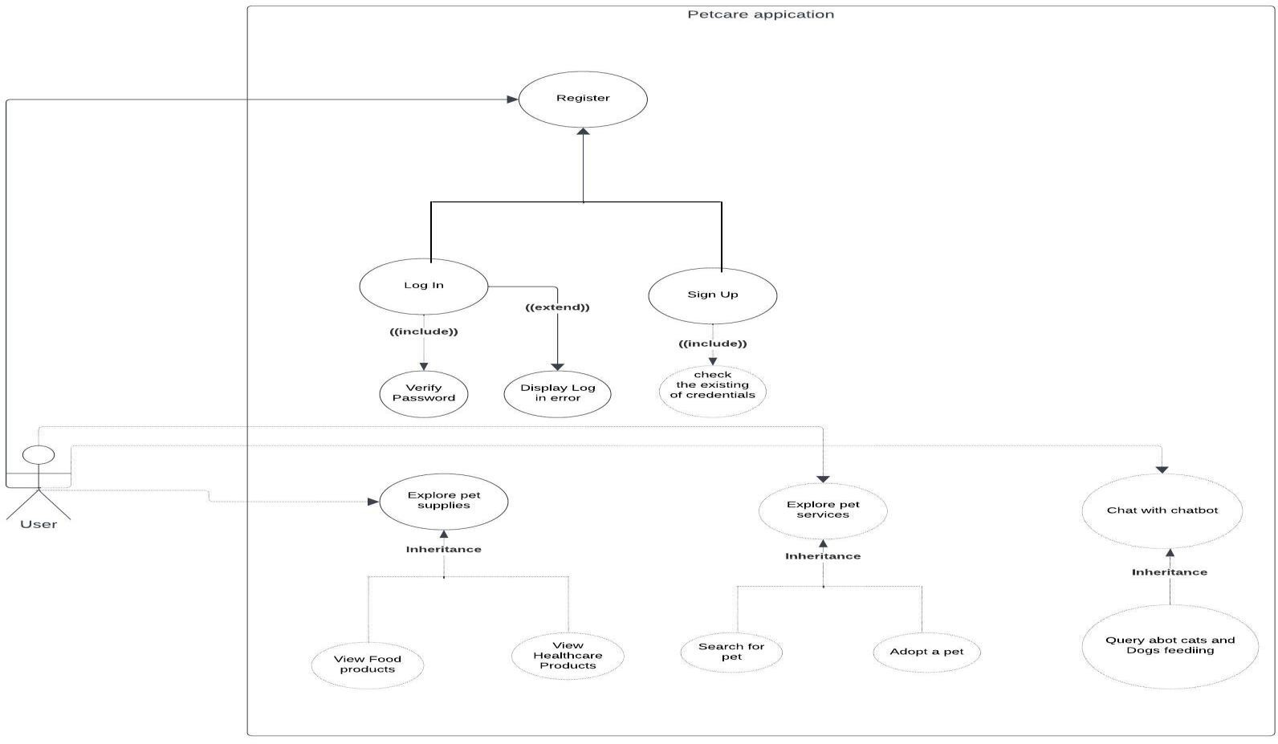

**Figure 2: Use case diagram for the pet care app**

*For the chatbot: if the user asks any questions regarding cat care it should be answered accordingly even with spelling mistakes, and not so well-defined answer.

For pet search : user upload a photo of their lost cat or dog , and then the system response with the top matches images of pets and data (user name , phone number for communicating regarding the pet that users found )

### class diagram:

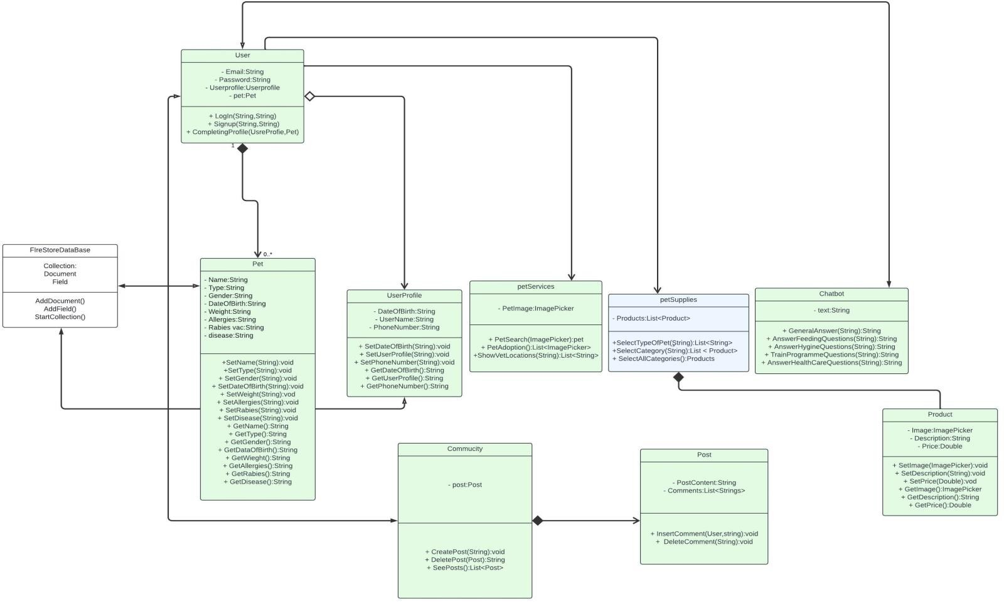

**Figure 3 : class diagram for the pet care application**

### ,4 sequence diagram:

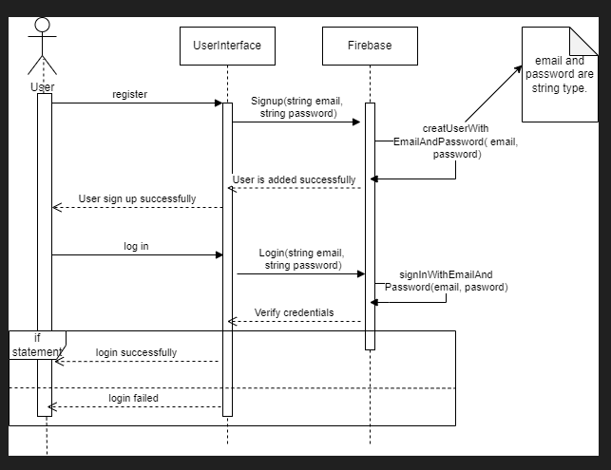

**Figure 4 : sequence diagram for the login function after registration**

### ,5 pet search flowchart diagram :

**Figure 5 : pet search flowchart diagram**

## Design and Implementation:

### User Interface Design:

**Mobile App UI:** Our pet care application consists of a set of screens that represent the application user interface (UI) and the physical structure. Let us view the screens that form the application:

**Log in screen:** Is the first screen in the application where the user enters his credentials in the

Text field widget in flutter. It provides the log-in process that includes the authentication procedure to check if the user account is correct and prevents the others from accessing unauthorized sections or data in the application. Log in screen consists of Log in button to navigate to home screen and sign-up text button to navigate to home screen.

**Home page screen:** Display the major features the application offered. The home page screen consists of a button to navigate to pet supplies, button to navigate and discover pet services feature and button to chat with assistant chat bot.

**Pet supplies screen:** Consists of a list of pets that the application provides supplies for (cats- dogs-rabbits) and for each pet there is a sub list of categories (food –healthcare products).

**Pet services screen:** Consists of a list of services that the application provides (pet search-pet adoption-pet shops location).

**Chatbot screen**: consist of a chat where the user enters their desired question in the message box and rasa server respond back with a message box consisting of the answer to the question

**Pet search page:** consist of button “named upload image”

### System Architecture Implementation:

###### *Mobile App Development:

###### *Backend services:

**Authentication:** service provided by Firebase that verifies user credentials and registers a new user.

**FireStore:** Service provided by Firebase that provides the app with a no SQL document database. It offers advanced querying capabilities, so it enables the application to store the information related to the user profile such each user has a unique ID relate the user account to the user profile.

###### Data storage:

The data in our application is now as we mentioned the data related to the user profile and is stored in Firestore by the firebase.

###### Authentication and Authorization:

The authentication is managed by authentication by firebase. Each user has two credentials (Email – password), when the user starts to log in firebase authentication begin to check the entered credentials by the user if the email and password are existing then firebase return that user exists. In related way if the user authentication success, then this user is authorized to use all features in the application and his data in the application.

###### Chat bot Development:

###### Rasa part:

1. Train Rasa NLU models with the provided intents to understand and classify user messages. We implement it by using the provided nlu.yml training data. Utilizes a pipeline of components like tokenizer, classifier, and synonym mapper.

Implement Rasa Core to manage the dialogue flow (stories) and handle user requests based on the recognized intents. We implemented it by using the provided stories.yml and domain.yml. Utilizes a pipeline of policies for predicting actions based on user input and previous interactions.

**Rasa NLU:** This component is responsible for natural language understanding. It processes user messages and classifies them into specific intents (e.g., greet, goodbye, inquire- daily_cat_food_amount) and extracts entities (specific pieces of information like cat food type or feeding guidelines).

Rasa Core: Once the intent and entities are identified by Rasa NLU, Rasa Core takes over to manage the dialogue flow. It determines how the chat bot should respond based on the recognized intents and maintains context throughout the conversation. Actions defined in Rasa Core can trigger responses, call external APIs, or perform custom logic.

So, the AI part involves training Rasa NLU models with examples for each intent and configuring Rasa Core to handle the dialogue based on the recognized intents. The provided intents in the Rasa NLU training data represent the AI's understanding of user inputs and guide the system's behavior.

**Pet search development:**

1. Animal Detection and Species Classification. In this layer, the animal is detected, and its class is recognized as either cat or dog. We used Convolutional Neural Networks (CNN) as the classification algorithm . YOLO V4 is a pre-trained one-stage object detection network, consisting of 53 convolution layers. We have applied transfer learning with pre-trained weights on the COCO dataset. The images of the detected animal with the use of segmentation techniques were cropped and connected to the next layers for identification purposes. By doing so, the noise in the image is reduced, and we only consider the animal part in the photos for identification. Animal detection is a crucial component that enhances identification efficiency, as it reduces the search space and minimizes the time required for identification. Furthermore, the classification step can be bypassed if the animal finder inputs the species into an API that connects user inputs to the framework. Our research is designed to be integrated into an app, which means that if the user specifies the species, the system will skip the classification step and proceed to step 2.
2. Face Detection and Land Marking. We utilized an API from the Roboflow platform for face detection and trained a pre-trained MobileNetV2 model with additional neural network layers. This custom model achieved an accuracy of 94%, enhancing the capability to detect and mark facial features accurately. The detected faces were cropped and transferred to the face alignment layer. The number of key points used for landmarking for cats and dogs is five (two eyes, two ears, and the nose).
3. Face alignment. Based on the labeled dataset, we elaborated on the above; we consider the eyes of the animals to be the baseline for face alignment . We then calculate the angle (β) between the x-axis and the line connecting the animal’s eyes. Based on this angle, we rotate the image to align the eyes horizontally. Figure 4 illustrates an example of this procedure.

1. Feature Extraction. After obtaining animals’ faces and bodies, we transform these images into numerical features.
2. Comparison. Face alignment techniques provide us with a baseline for comparing different animal faces together, the comparison of the faces is performed after alignment, we used hamming similarity. Each image was processed to extract its features, and these feature vectors were then compared using the Hamming distance. This distance measures the number of differing bits between two binary vectors, effectively quantifying the similarity between images. Despite Hamming distance typically being used for binary data, its application here proved effective, potentially due to the specific nature of the image features and their representation, leading to improved matching performance in our use case.
3. Recommendations. The top N results of the comparison are presented to this layer. The top match means that the similarity value of comparison from the previous step is the highest. We searched the database to find the top animals’ names with the IDs found and recommend them to the user who queried the image.

## Integration of Mobile App and Chat bot:

## Communication Protocols

**Hosting the Rasa Chatbot:** The Rasa chatbot server is made publicly accessible using ngrok. Ngrok creates secure tunnels to the Rasa server, providing a public URL that allows the chatbot to be accessed via an API endpoint. This setup facilitates communication with external clients such as the Flutter app, enabling seamless interaction.

**Communication Overview:** The communication between the Flutter app and the Rasa chatbot is orchestrated through HTTP requests. The app sends user queries to the Rasa server using POST requests, while the server processes these queries and generates appropriate responses. This communication flow follows a request-response model, where the app initiates the interaction by sending messages, and the chatbot responds accordingly.

By adhering to standard RESTful principles and utilizing the JSON data format, the communication between the app and the chatbot is structured and efficient. The ngrok tunnel handles incoming requests from the app, forwards them to the Rasa chatbot, and relays the responses back to the app. This approach ensures real-time, bi-directional communication, enabling a seamless conversational experience for the users.

Communication Protocols:

The communication between the Flutter app and the Rasa chatbot is facilitated through HTTP requests. Below are the details of the communication protocols utilized in this integration:

1. **Request-Response Model:**
   * The interaction between the Flutter app and the Rasa chatbot follows a request-response model, where the Flutter app sends HTTP requests to the Rasa server, and the server responds with the appropriate data.
2. **HTTP Methods:**
   * **POST Requests:**
     + POST requests are primarily used for sending user queries from the Flutter app to the Rasa server. These requests contain the user's message in the request body, allowing the Rasa server to process the query and generate a suitable response.
   * **GET Requests:**
     + GET requests can be employed for fetching additional data or resources from the Rasa server if required by the Flutter app. However, in most cases, the communication relies on POST requests for sending queries and receiving responses.
3. **RESTful API:**
   * The Rasa server exposes a RESTful API, allowing the Flutter app to interact with the chatbot's functionalities. The API endpoints define the operations that can be performed, such as sending messages, retrieving conversation history, or managing chatbot settings.
4. **JSON Data Format:**
   * Both request payloads and response payloads are formatted as JSON (JavaScript Object Notation). This format ensures compatibility and ease of data parsing between the Flutter app and the Rasa server. JSON objects typically contain fields such as "message" for user queries and "response" for chatbot replies.
5. **ngrok Tunnel:**
   * An ngrok tunnel is used to make the Rasa server publicly accessible. Ngrok provides a public URL that acts as the intermediary between the Flutter app and the Rasa chatbot. This URL handles incoming HTTP requests from the Flutter app, forwards them to the Rasa server, and relays the responses back to the Flutter app.
6. **HTTPS (Optional):**
   * For enhanced security, HTTPS (Hypertext Transfer Protocol Secure) can be implemented to encrypt communication between the Flutter app and the Rasa server. HTTPS ensures the confidentiality and integrity of data transmitted over the network, protecting user privacy and preventing unauthorized access.

### Data Flow Between Mobile Application and Chat bot:

1. **User Interaction:** Users engage with the chat interface in the mobile app.
2. **HTTP Request Generation:** The app generates an HTTP POST request with the user query.
3. **Transmission to Rasa Server via ngrok:** The request is sent to the public URL provided by ngrok, which tunnels to the Rasa server.
4. **Processing by Chatbot:** Rasa processes the query and generates a response.
5. **Response Generation:** The chatbot crafts a response message.
6. **HTTP Response Transmission:** The Rasa server sends the response back through the ngrok tunnel, which relays it to the app.
7. **Display in App:** The app displays the chatbot's response to the user.

This streamlined process ensures smooth communication and interaction between the mobile app and the chatbot.

## Integration of Mobile App and pet match feature:

## Communication Protocols

**Hosting the local server:** The local server of the pet match model is made publicly accessible using ngrok. Ngrok creates secure tunnels to the local server, providing a public URL that allows the local server to be accessed via an API endpoint. This setup facilitates communication with external clients such as the Flutter app, enabling seamless interaction.

**Communication Overview:** The communication between the Flutter app and the local server is orchestrated through HTTP requests. The app sends an image(in the format of jpg) to the local server using POST requests, while the server processes this image and generates appropriate the top matches

Communication Protocols:

Communication between the Flutter app and the local server is facilitated through HTTP requests. Below are the details of the communication protocols utilized in this integration:

**HTTP Methods:**

* + **POST Requests:**
    - POST requests are primarily used for sending user pet image from the Flutter app to the local server. These requests contain the user's pet image in the request body, allowing the local server to process the image and generate the top matches.

**JSON Data Format:**

* + Both request payloads and response payloads are formatted as JSON (JavaScript Object Notation). This format ensures compatibility and ease of data parsing between the Flutter app and the local server.

**ngrok Tunnel:**

* + An ngrok tunnel is used to make the local server publicly accessible. Ngrok provides a public URL that acts as the intermediary between the Flutter app and the local server. This URL handles incoming HTTP requests from the Flutter app, forwards them to the local server, and relays the responses back to the Flutter app.

### Data Flow Between Mobile Application and Chat bot:

1. **User Interaction:** Users upload image of the lost pet with the pet matching interface in the mobile app.
2. **HTTP Request Generation:** The app generates an HTTP POST request with the user pet image.
3. **Transmission to local Server via ngrok:** The request is sent to the public URL provided by ngrok, which tunnels to the local server.
4. **Processing by model:** the model processes the image and generates the top matches.
5. **HTTP Response Transmission:** The local server sends the response back through the ngrok tunnel, which relays it to the app.
6. **Display in App:** The app displays the top matches images of the lost pets with the user name and phone number response to the user.

# Chapter 5: Conclusion

## Contributions of the Project:

The project brings four significant contributions to the realm of pet ownership, offering an enriching experience for pet owners. The following key contributions highlight the positive impact this project aims to make:

**Convenient Access to Pet Supplies**: By providing a centralized platform for purchasing pet supplies, the project contributes to the convenience of pet owners. Users can easily access and shop for a diverse range of high-quality pet products, ensuring the well-being and comfort of their pets.

**Expert Guidance**: The inclusion of an AI-powered chat expert in the Application contributes to personalized and real-time assistance for pet owners. This feature empowers users with expert guidance on health queries, behavior concerns, and general pet care, enhancing their confidence and knowledge in making informed decisions for their pets.

**Pet Services** such as clinic information: The Application offers a comprehensive pet services section, combining a dedicated clinic information service where the user can find the desired clinic information such as (clinic phone number , address and the clinic website link)

**Community Engagement**: The Application establishes a vibrant community where users can post, share, and engage in discussions related to their pets. This community feature fosters a sense of camaraderie among pet owners, providing a space for sharing experiences, seeking advice, and building connections within the pet-loving community.

**Pet matches**: The Pet Match feature enhances the pet care app by providing a crucial service for pet owners seeking to reunite with their lost pets. By allowing users to upload images of their pets and matching them with a database of found pets, this feature helps increase the chances of successful reunions. This feature significantly improves user engagement and trust in the Pet Care platform, adding a valuable dimension to its comprehensive suite of pet care services.

## Progress:

**Current Status:**

**Application Development:**

1. **Front-end Development:**
   * Finalized using Flutter:
     + Login Page
     + Sign-Up Page
     + Profile Page
     + Pet Services Page
     + Pet Supplies Page
2. **Back-end Development:**
   * Connected the application with Firebase.
   * Implemented the login function.
   * Implemented the sign-up function.
   * Implemented the show profile function.
3. **Pet Supplies Page:**
   * Finalized back-end development:
     + This section includes all essential products that pets need such as food, treats, healthcare, grooming, accessories, and toys.
4. **Pet Services:**
   * Finalized back-end development:
     + **Clinic information Service**: Enables users to find clinic information such as phone number, website link and address .
5. **Community Section**: Allows users to post questions and receive answers from other users.

**Chat-bot Development:**

1. **Data Gathering and Sorting:**
   * Collected and organized data relevant to pet care.
2. **Rasa Model Training:**
   * Trained the Rasa model to handle various pet care queries.
3. **Front-end Web Page Development:**
   * Developed the front-end web page for the chat-bot.
4. **Flask Web Application Development:**
   * Developed the Flask web application to integrate with the chat-bot.
5. **Completed Chat-bot Development:**
   * Enhanced the chat-bot by adding more pet types and topics, including training, hygiene, and health.

**search part development:**

## Future work :

## Collecting more data

**More Reliable and Accurate Data Collection**:

While initial data collection mechanisms were implemented, their reliability and accuracy are limited by restricted access to comprehensive websites and books that provide in-depth and well-researched information.

**Enhancing Security**:

Enhanced security measures are necessary but not fully implemented due to resource constraints. Where the current deployment using the Ngrok tool exposes the server and data to potential vulnerabilities.

• **Cloud Deployment**:

The application is not currently deployed through cloud services, limiting its scalability and flexibility. Future work should involve deploying the application on a robust cloud platform to facilitate seamless updates, maintenance, and disaster recovery capabilities.

• **Improved Pet Search Model Accuracy**:

The pet search model's accuracy can be improved by incorporating advanced machine learning algorithms and increasing the diversity and volume of training data. However, this requires additional resources that are not currently available.

• **AI Chatbot Response Time**:

The AI chatbot does not consistently generate responses within 3 seconds for 90% of user queries. Future work should focus on optimizing the underlying algorithms and infrastructure to enhance response times.

• **Application Response Time**:

The application does not meet the desired response time of 2 seconds for 95% of user interactions due to current performance limitations due to the limitation of the current computing power. Future improvements should aim at optimizing both front-end and back-end processes to reduce latency.

• **Scalability**:

The system is not currently designed to handle a growing number of users without performance degradation. Future work should focus on optimizing the architecture and utilizing load balancing techniques to support scalability.

• **Support for Concurrent Users and Transaction Throughput:**

Currently, the application supports only 100 concurrent users, and the backend services struggle to process 1,000 transactions per minute during peak times without failures. Future improvements should focus on significantly enhancing the infrastructure and optimizing both database queries and server performance. These enhancements aim to increase the capacity to support up to 100,000 concurrent users and handle high transaction volumes efficiently

# Chapter 6: References

## References links:

##### An course for developing the chatbot on Udemy

##### . [https://www.udemy.com/course/mastering-chatbots-using-botpress-rasa-and-](https://www.udemy.com/course/mastering-chatbots-using-botpress-rasa-and-transformers/?fbclid=IwAR1Ruu6mIeB8p0dKEmNsD1QwPUY3W9d5MFzLqhOPD8FZGfmmZLrQJkL04d4) [transformers/?fbclid=IwAR1Ruu6mIeB8p0dKEmNsD1QwPUY3W9d5MFzLqhO](https://www.udemy.com/course/mastering-chatbots-using-botpress-rasa-and-transformers/?fbclid=IwAR1Ruu6mIeB8p0dKEmNsD1QwPUY3W9d5MFzLqhOPD8FZGfmmZLrQJkL04d4) [PD8FZGfmmZLrQJkL04d4](https://www.udemy.com/course/mastering-chatbots-using-botpress-rasa-and-transformers/?fbclid=IwAR1Ruu6mIeB8p0dKEmNsD1QwPUY3W9d5MFzLqhOPD8FZGfmmZLrQJkL04d4)

##### Purina website is used for data collection

##### <https://www.purina.co.uk/articles/cats>

##### <https://www.petsnvets.org/>

##### <https://www.akc.org/>

##### <https://www.petfinder.com/>

##### <https://alohavet.com/index.php>

##### <https://www.life-with-siamese-cats.com/>

##### <https://www.pawlicy.com/>

##### <https://siamesekittykat.com/>

##### <https://vcahospitals.com/>

* + - Dorling Kindersley, (2014), The Cat Encyclopedia, Sarah Larter

Appendices

1 Code Snippets

Rasa NLU :

* intent: Choosing_Suitable_Walking_Routes_for_Cats examples: |
  + How can you choose suitable walking routes for your cat, taking into consideration their individual preferences, safety, and exposure to potential hazards?
  + In what ways can you select appropriate walking routes for your cat, considering factors like their individual preferences, safety, and exposure to potential hazards?
  + What considerations should be taken into account when choosing walking routes for your cat, with a focus on their individual preferences, safety, and avoiding potential hazards?
  + How do you ensure that the walking routes for your cat are suitable, considering their individual preferences, safety, and minimizing exposure to potential hazards?
  + What steps can you take to choose walking routes that cater to your cat's individual preferences, prioritize safety, and minimize exposure to potential hazards?
  + How can you tailor walking routes for your cat based on their individual preferences, safety requirements, and avoidance of potential hazards?
  + What factors should you consider when selecting walking routes for your cat, emphasizing their individual preferences, safety, and mitigating potential hazards?
  + In what ways can you evaluate and choose suitable walking routes for your cat, considering their individual preferences, safety concerns, and potential hazards?
  + What precautions should you take when choosing walking routes for your cat to ensure they align with their individual preferences, safety, and minimize exposure to potential hazards?
  + How can you customize walking routes for your cat, considering their individual preferences, safety measures, and minimizing exposure to potential hazards?

Rasa core:

1. rasa story
   * story: Q87 steps:
     + intent: Choosing_Suitable_Walking_Routes_for_Dogs
     + action: utter_Q87
2. rasa domine utter_goodbye:
   * text: "Bye"

2 Screenshots

Screenshots for application screens:

|  |  |
| --- | --- |
|  |  |

**Figure 5: Log in screen Figure 6: Sign Up screen**

|  |  |
| --- | --- |
|  |  |

**Figure 7: Home page screen Figure 8: Home page screen**

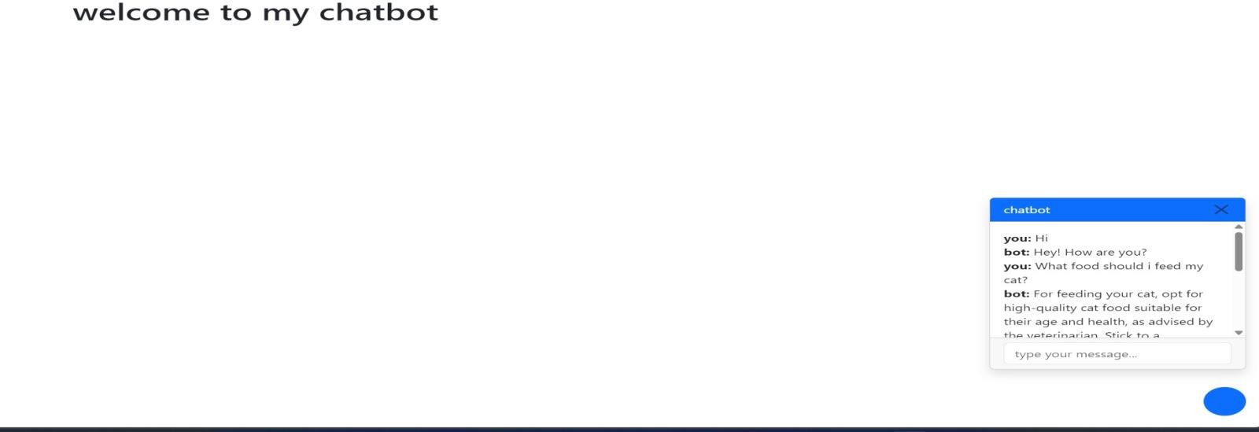

**Figure 9: Chat-bot Screen**